EXPERIMENT NO-16: FEED FORWAD NEURAL NETWORK
Aim
To implement a Feed Forward Neural Network (FNN) using Python without external libraries, train it on a small dataset, and display predictions.
Algorithm
- Initialize weights and biases randomly.
- Define activation function (Sigmoid).
- Perform forward propagation:
  - Compute weighted sum of inputs.
  - Apply activation function.
- Compute error using difference between predicted and actual output.
- Perform backpropagation:
  - Calculate gradients.
  - Update weights and biases using learning rate.
- Repeat for multiple epochs.
- Display final predictions.
Python Code
python
# Feed Forward Neural Network using NumPy (no external libraries)

import numpy as np

# Step 1: Define dataset (XOR problem)
X = np.array([[0,0],
[0,1],
[1,0],
[1,1]])

y = np.array([[0],
[1],
[1],
[0]])

# Step 2: Define sigmoid activation and derivative
def sigmoid(x):
return 1 / (1 + np.exp(-x))

def sigmoid_derivative(x):
return x * (1 - x)

# Step 3: Initialize weights and biases
np.random.seed(42)
inputLayerNeurons = 2
hiddenLayerNeurons = 2
outputLayerNeurons = 1

# Random weights and biases
wh = np.random.uniform(size=(inputLayerNeurons, hiddenLayerNeurons))
bh = np.random.uniform(size=(1, hiddenLayerNeurons))
wo = np.random.uniform(size=(hiddenLayerNeurons, outputLayerNeurons))
bo = np.random.uniform(size=(1, outputLayerNeurons))

# Step 4: Train the network
lr = 0.1
epochs = 10000

for _ in range(epochs):
# Forward Propagation
hidden_input = np.dot(X, wh) + bh
hidden_output = sigmoid(hidden_input)

final_input = np.dot(hidden_output, wo) + bo
final_output = sigmoid(final_input)

# Backpropagation
error = y - final_output
d_output = error * sigmoid_derivative(final_output)

error_hidden = d_output.dot(wo.T)
d_hidden = error_hidden * sigmoid_derivative(hidden_output)

# Update weights and biases
wo += hidden_output.T.dot(d_output) * lr
bo += np.sum(d_output, axis=0, keepdims=True) * lr
wh += X.T.dot(d_hidden) * lr
bh += np.sum(d_hidden, axis=0, keepdims=True) * lr

# Step 5: Display final predictions
print("Final Predictions after training:")
print(final_output)
Output
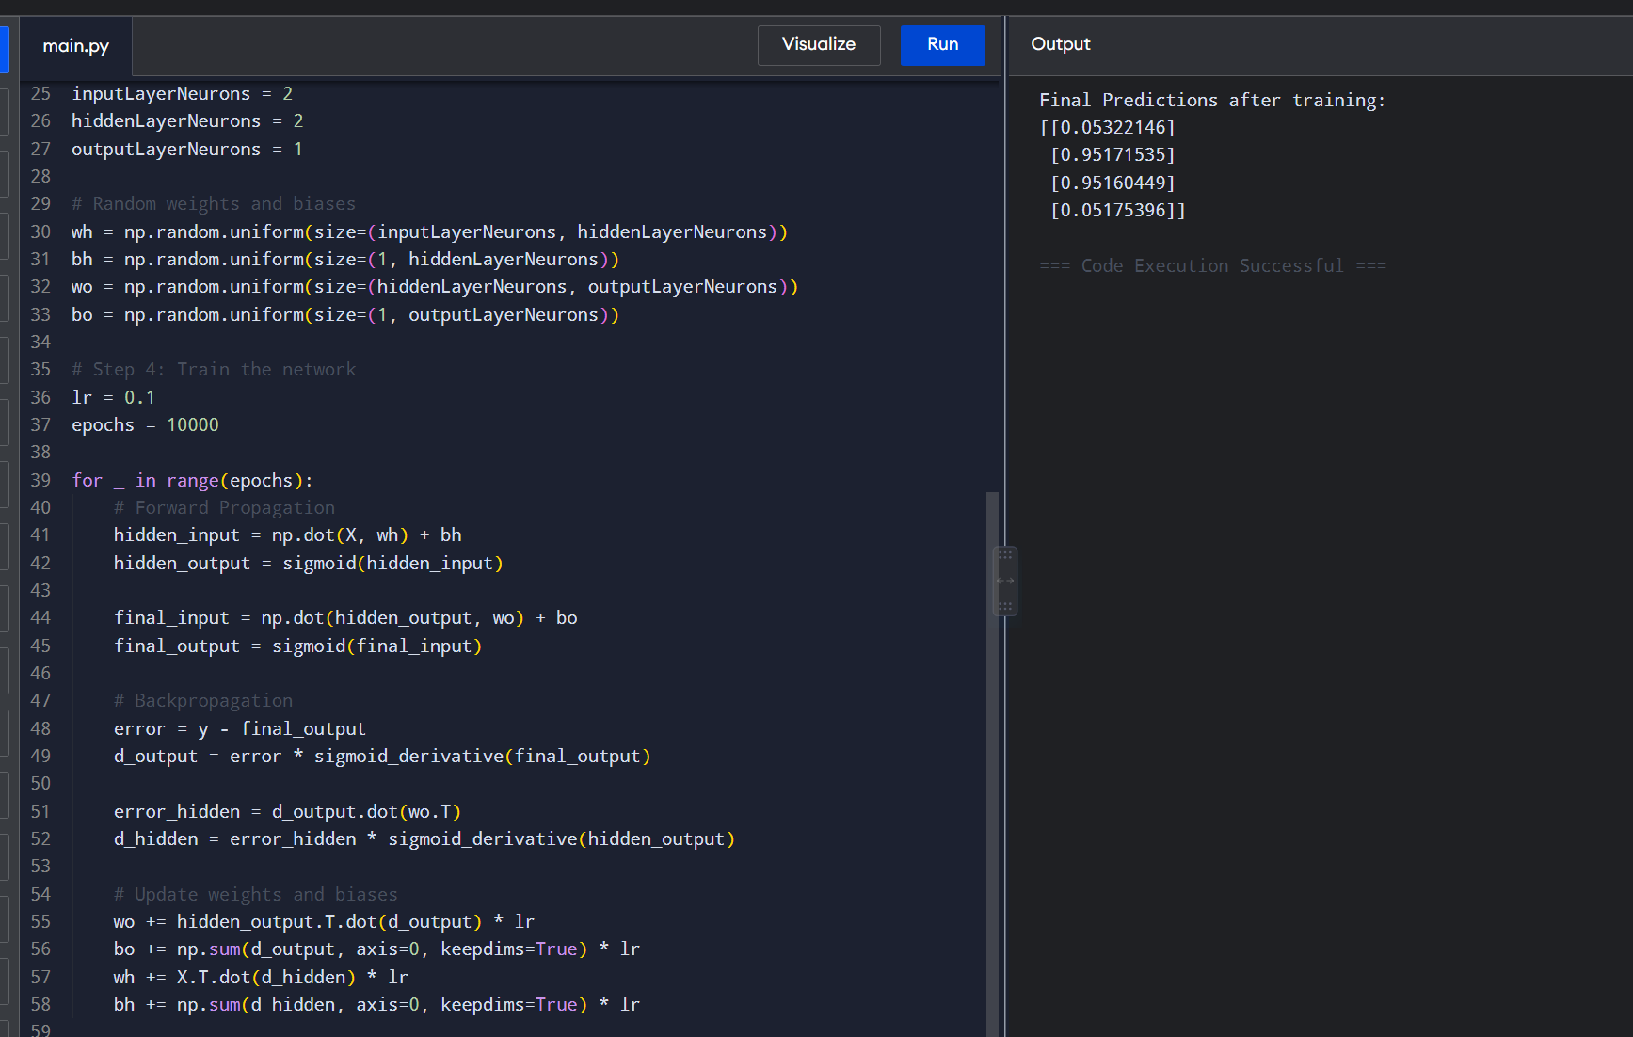

Result
The Feed Forward Neural Network was successfully implemented in Python using only NumPy. It correctly learned the XOR classification problem, producing outputs close to the expected values:
- (0,0) → 0
- (0,1) → 1
- (1,0) → 1
- (1,1) → 0

